Suggested Age Range: 6 - 7 years; 7 - 8 years; 8 - 9 years; 9 -10 years;
UK Curriculum: Key Stage Two (Lower)
Suggested UK Year Group: Year Three
UK Primary Curriculum Link: Rocks
Science Subject: What are Meteors? What are Comets?
Science Questions: What are Meteors and Comets made of?
Suggested Science Activity: Edible Comets
Children with SEND: Use to boost comprehension of vocabulary
EAL children: Beginners Level
Country of Origin: First Nations of America
Source: The Feather Moon by Lynn Moroney

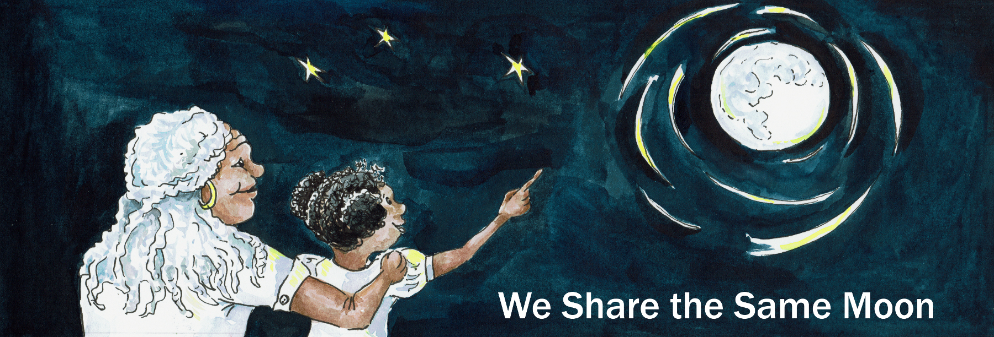
Long ago, when the world began. The stars shone in the sky so brightly, they seemed to shimmer and sparkle. It looked as if they were dancing through the sky.

Coyote, the wild dog of America, he used to go out into long, long grass of the prairie and gaze up at the stars at night.

He would look up at the stars and wish and wish and wish that he could join them and dance across the sky.

One night, Coyote plucked up courage to ask,
“Stars, why don’t you let me join you and dance across the Sky?”

“Nonsense!” said a voice from above. It was one of the Stars answering him back!
“You can’t dance with us! You belong on Earth!”

“Oh stars ” said Coyote “Please let me dance with you! I am very good dancer down here on Earth! I bet I could show you a move or two!”

“Coyote!” laughed the stars “You cannot dance with the stars! You may be a good dancer but you will never keep up with us!”

"I am not just a good dancer - I am the best!” said Coyote.
“Please let me dance with you and show you what I can do!”

“Coyote, you may be the best dancer on Earth! But you still will not be able to keep up with us!” said the Stars. "We dance all night across the Sky”.

"So can I” said Coyote “I can dance all night too! Please stars, please let me dance with you!”

A small blue star took pity on Coyote, she had a soft heart and Coyote looked so mournful down there all alone in the prairie.

“Very well! she said You can come and dance with me, Coyote!”
“But, we dance across the sky all night and you must keep up with me!
Whatever happens, you must not stop. You must - Keep Dancing!”
“Can you do that Coyote?”

“Yes, yes, yes I can!” Coyote yelped with joy “Thank you, thank you, thank you!”

So, the blue star reached down to him, and he reached up to her.
And when his paw touched the Star’s hand,
Coyote felt himself grow lighter and lighter and lighter!
His paws began to float off the ground and he rose up into the Sky!
“Woowee!” he thought.”This is really something.”

And then the two of them began to dance across the Sky.

And so they
Danced to the left, they danced to the right and they swung each other around and around. They danced to the left, they danced to the right and they swung each other around and around.

“Woowee” thought Coyote “This is some dancing!”

So they

Danced to the left, they danced to the right and they swung each other around and around. They danced to the left, they danced to the right and they swung each other around and around.

And so they carried on and on dancing!

They
Danced to the left, they danced to the right and they swung each other around and around. They danced to the left, they danced to the right and they swung each other around and around.

But the night was long and Coyote began to run out of breath.
"Can’t we dance a little slower?” he asked the Star.
“Come on Coyote - the night is young and we still have so much sky left!”
“We must - Keep Dancing!”

So they

Danced to the left, they danced to the right and they swung each other around and around. They danced to the left, they danced to the right and they swung each other around and around.

On and on and on!
Coyote was a good dancer, but, he began to tire.
“Please Star, why can’t we stop for a little while?’ he begged.
“I told you NO! We cannot stop, we must keep up with the rest of the stars.”
“We must - Keep Dancing!”

Poor Coyote, his legs hurt, his paws hurt, his chest felt like it was on fire!

“I cant, I cant, I can’t keep on dancing! I must, I must …”
And his paw slipped from the Star’s grasp. And he slid all the way back down to Earth!

But, as he slid down, he began to change …
His began to glow brighter and brighter and brighter and his body became an arrow of light shooting across the sky! Until he landed splash into the lake below!
And so Coyote became the very first shooting star!

And some people say that if you look up at the sky at night and see a shooting star ….
Well, it must be Coyote trying and failing to dance with the stars once again.

But … scientists say that a shooting star isn’t really a star at all!
But a fragment of space rock burning as it hits the Earth’s atmosphere.

But which do YOU think is true?

Copyright: Cassandra Wye May 2019

